Ultimate AWS Three-Tier Enterprise Architecture
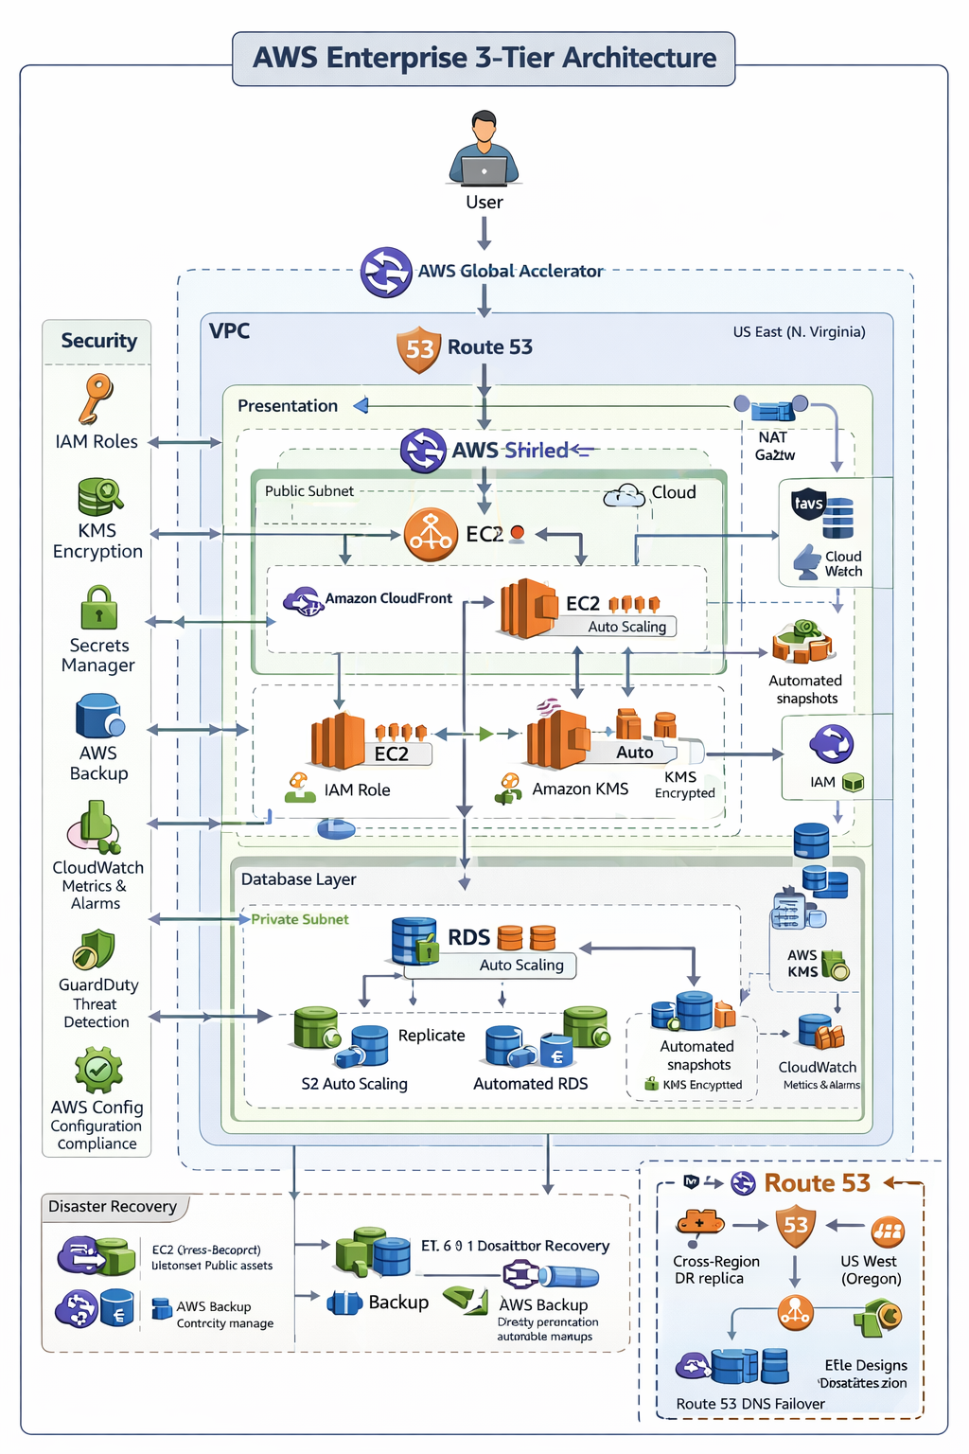

1️⃣ Architecture Diagram
- User → Global Accelerator → Route 53 → AWS Shield → WAF → CloudFront → ALB → EC2 (Auto Scaling) → RDS (Private Subnet)
- Security layers: IAM, KMS, Secrets Manager, Parameter Store
- DR & Backups: Elastic DR, Multi-AZ RDS, Cross-region snapshots, S3 replication
- Monitoring: CloudWatch, GuardDuty, CloudTrail, Config

2️⃣ VPC & Networking
Console: 1. Create VPC 10.0.0.0/16 2. Subnets: Public 10.0.1.0/24, Private 10.0.2.0/24 3. IGW → Attach 4. NAT Gateway → Public subnet 5. Route Tables → Public → IGW, Private → NAT
CLI:
aws ec2 create-vpc --cidr-block 10.0.0.0/16 --tag-specifications 'ResourceType=vpc,Tags=[{Key=Name,Value=ThreeTierVPC}]'
aws ec2 create-subnet --vpc-id <VPC_ID> --cidr-block 10.0.1.0/24
aws ec2 create-subnet --vpc-id <VPC_ID> --cidr-block 10.0.2.0/24
aws ec2 create-internet-gateway
aws ec2 attach-internet-gateway --vpc-id <VPC_ID> --internet-gateway-id <IGW_ID>
aws ec2 allocate-address
aws ec2 create-nat-gateway --subnet-id <PUBLIC_SUBNET_ID> --allocation-id <EIP_ALLOC_ID>

3️⃣ IAM & Security
Console: - IAM Roles: EC2 → Policies: S3ReadOnly, CloudWatchAgent - KMS CMK → Use for EBS, RDS, S3 - Secrets Manager → DB credentials → Rotation - Parameter Store → Encrypted configs
CLI:
aws iam create-role --role-name EC2AppRole --assume-role-policy-document file://trust-policy.json
aws iam attach-role-policy --role-name EC2AppRole --policy-arn arn:aws:iam::aws:policy/AmazonS3ReadOnlyAccess
aws kms create-key --description "ThreeTierCMK"
aws secretsmanager create-secret --name DBSecret --secret-string '{"username":"admin","password":"Passw0rd!"}'
aws ssm put-parameter --name "/ThreeTierApp/DBEndpoint" --value "mydb.123456789.us-east-1.rds.amazonaws.com" --type SecureString

4️⃣ EC2/EKS + Auto Scaling + ALB
Console: - EC2 Launch Template → Attach IAM Role → EBS encrypted - EKS Cluster → Node Groups → Attach IAM Role, enable Auto Scaling - Auto Scaling Group → Multi-AZ → Attach ALB - ALB → HTTPS → ACM certificate
CLI:
# EC2
aws ec2 run-instances --image-id ami-0abcdef1234567890 --count 1 --instance-type t3.micro --key-name MyKeyPair --subnet-id <PUBLIC_SUBNET_ID> --iam-instance-profile Name=EC2EKSRole --block-device-mappings '[{"DeviceName":"/dev/sda1","Ebs":{"VolumeSize":20,"Encrypted":true}}]'
# EKS
aws eks create-cluster --name ThreeTierEKS --role-arn <IAM_ROLE_ARN> --resources-vpc-config subnetIds=<PUBLIC_SUBNET_ID>,securityGroupIds=<SG_ID>
aws eks create-nodegroup --cluster-name ThreeTierEKS --nodegroup-name NodeGroup1 --node-role <IAM_ROLE_ARN> --subnets <PUBLIC_SUBNET_ID> --scaling-config minSize=1,maxSize=3,desiredSize=2

5️⃣ CloudFront + WAF + Shield + Global Accelerator
Console: - CloudFront → Origin: ALB → Attach WAF & Shield - Global Accelerator → Add ALB endpoint → Enable health checks
CLI:
aws cloudfront create-distribution --distribution-config file://cf-distribution.json
aws wafv2 create-web-acl --name ThreeTierWAF --scope CLOUDFRONT --default-action Allow --rules file://waf-rules.json --visibility-config SampledRequestsEnabled=true,CloudWatchMetricsEnabled=true,MetricName=ThreeTierWAF
aws globalaccelerator create-accelerator --name ThreeTierGA --ip-address-type IPV4 --enabled

6️⃣ RDS Multi-AZ + Backups + DR
Console: - RDS → Multi-AZ → KMS encryption → Automated backups → Cross-region snapshots - Elastic DR → Enable EC2 replication to DR region
CLI:
aws rds create-db-instance --db-instance-identifier ThreeTierDB --db-instance-class db.t3.micro --engine mysql --master-username admin --master-user-password Passw0rd! --allocated-storage 20 --vpc-security-group-ids <SG_ID> --multi-az --storage-encrypted --kms-key-id <KMS_KEY_ID> --backup-retention-period 7
aws rds copy-db-snapshot --source-db-snapshot-identifier <SNAPSHOT_ID> --target-db-snapshot-identifier CrossRegionSnapshot --source-region us-east-1 --kms-key-id <KMS_KEY_ID>

7️⃣ S3 + Backup + Replication
Console: - S3 → Versioning + Cross-Region Replication + KMS - AWS Backup → Daily schedule → EC2 + RDS + S3
CLI:
aws s3api put-bucket-versioning --bucket my-three-tier-bucket --versioning-configuration Status=Enabled
aws s3api put-bucket-replication --bucket my-three-tier-bucket --replication-configuration file://replication.json
aws backup create-backup-plan --backup-plan file://backup-plan.json

8️⃣ Monitoring & Logging
Console: - CloudWatch → Alarms, metrics - CloudTrail → Enable logging → S3 bucket (encrypted) - GuardDuty → Enable - Config → Track resource changes
CLI:
aws cloudwatch put-metric-alarm --alarm-name EC2HighCPU --metric-name CPUUtilization --namespace AWS/EC2 --statistic Average --period 300 --threshold 80 --comparison-operator GreaterThanThreshold --dimensions Name=InstanceId,Value=<INSTANCE_ID> --evaluation-periods 2 --alarm-actions <SNS_TOPIC_ARN>
aws cloudtrail create-trail --name ThreeTierTrail --s3-bucket-name my-cloudtrail-bucket --is-multi-region-trail
aws cloudtrail start-logging --name ThreeTierTrail
aws guardduty create-detector --enable

9️⃣ Failure Simulation Scenarios
Failure | Console | CLI
Stop EC2 | EC2 → Stop Instance → Observe ASG | aws ec2 stop-instances –instance-ids
RDS Failover | RDS → Failover | aws rds reboot-db-instance –db-instance-identifier ThreeTierDB –force-failover
Delete S3 Object | S3 → Delete → CloudFront invalidation | aws s3 rm s3://my-three-tier-bucket/index.html
Disable KMS Key | KMS → Disable | aws kms disable-key –key-id
Route 53 Failover | Disable primary → GA routes to DR | aws route53 change-resource-record-sets –change-batch file://failover.json

10️⃣ Interview-Ready Talking Points
- Multi-layer security: IAM roles, KMS encryption, Secrets Manager, WAF, Shield
- DR & Backup: Elastic DR, Multi-AZ RDS, S3 replication, AWS Backup
- Monitoring: CloudWatch, GuardDuty, CloudTrail, Config
- Auto-healing: ASG, ALB health checks, RDS Multi-AZ failover
- Global performance: CloudFront + Global Accelerator

This is a complete end-to-end guide for a new DevOps engineer to deploy, secure, monitor, backup, and demonstrate a fully resilient AWS three-tier architecture.

